Hate Crime in Massachusetts

2020



Massachusetts Executive Office of Public Safety & Security

Massachusetts Hate Crimes, 2020

**Executive Summary**

**Notes on Data**

This report is written in accordance with Section 34 of Chapter 22C of the Massachusetts General Laws. The 2020 Hate Crime Report for Massachusetts was compiled using data voluntarily supplied by police departments across the Commonwealth. The Executive Office of Public Safety & Security (EOPSS) received a total of 385 reports of incidents of hate crime (up from 376 in 2019) from 85 municipal police departments, 9 campus police agencies, and the Massachusetts General Hospital Police Department. In addition, 271 agencies submitted “zero reports” (indicating that they had experienced no bias-motivated incidents) and there were 38 non-reporting agencies, down from 45 in 2019. In 2020, reporting agencies and zero-reporting agencies covered approximately 95% of the population of Massachusetts. After receipt and state data quality checks, EOPSS submits all Massachusetts hate crime data to the FBI for further analysis, verification, and inclusion in its annual *Hate Crime Statistics* publication. EOPSS continues to verify and update hate crime reports after submission to the FBI, and as a result, the data in this report may not match the FBI’s published data. In addition, the 2020 data the FBI released did not include a portion of Boston data as it was in the process of being reviewed at the time of the FBI deadline.

Data was collected utilizing two methods – the National Incident Based Reporting System (NIBRS) and the Uniform Crime Reporting System (UCR). 2020 was the last year that the FBI collected UCR data, fully transitioning to NIBRS for the 2021 data collection. Agencies that report data via NIBRS automatically upload their data to EOPSS. EOPSS then extracts the required data for analysis and forwards it to the FBI. Agencies that submitted via the Uniform Crime Report (UCR) filled out standardized FBI Hate Crime Workbooks and submitted those forms to EOPSS via an on-line portal. It is important to note that several of the categories displayed in this report may only be available from the NIBRS–reporting agencies, as NIBRS captures many data elements that UCR does not capture.

In 2020, 383 incidents were submitted via NIBRS from 93 agencies, while 2 were submitted via UCR.

**Bias Motivation**

A “hate crime,” which can be referred to interchangeably as a “bias crime” or “bias-related / motivated crime,” is not reported as a stand-alone offense, but rather as part of a separate criminal violation, ranging from vandalism to harassment to violent crimes. Of the 395 hate crime offenses reported in 2020, the most frequent offenses were Vandalism / Damage / Destruction of Property (32.9%), which is often graffiti or the defacing of property and Intimidation (30.6%). Simple Assault and Aggravated Assault incidents both had a significant portion of offenses accounting for 19% & 11.4% respectively. In terms of violent crime, there were 45 bias-motivated Aggravated Assaults reported in 2020, which is up from the 43 reported in 2019. Historically, Vandalism and Intimidation are the top two offenses reported during bias incidents and in recent years have each accounted for approximately 30% of offenses. (See Table 1.)

In 2020, similar to years past, prejudice against race / ethnicity or national origin was the most widely reported bias motivation representing 66.4% of the total (up from 51.3% in 2019). Bias against religious groups was the second most frequent bias motivation with 15.7% of the total (down from 24% in 2019). Sexual Orientation bias was third with 14.3% (down from 21.9% in 2019). (See Figure 1 & Table 2.)

**Victims and Offenders**

As in previous years, males were the most frequent victims (52.5% of known victims). This number has been in the 50-60% range for the past several years whereas prior numbers reached 70% of victims being reported as male as recently as 2012. The known offenders of hate crimes continue to be predominantly male with 78.1% of offenders identified as males. Females were victims in 47.5% of incidents where the sex of the victim was identified. Females as a percentage of offenders where sex was determined accounted for 21.9% (up from 16.4% in 2019). (For a breakdown of victims and offenders by gender, please refer to Tables 14 and 16.) When the race of the victim was determined by NIBRS agencies, whites were the most frequent racial category as victims 71.9% (up significantly from 53.8% in 2019). White offenders accounted for 77.5% of known offenders up from 72% in 2019. African American victims of both genders comprised 24.2% of the total victim population, down from 38% the previous year. African American offenders comprised 22.1% of offenders, down from 24.4% the previous year. (See Table 15.)

Victims were reported to have some type of injury in 11.3% of cases. This is an increase as compared to past years, where typical numbers hover around the 7-8% of incidents resulting in some injury. Of the 33 total injuries, 9 resulted in a major injury of some type which is a decrease from 13 in 2019. (See Table 17.)

**Location**

Bias incidents reported by police agencies in Massachusetts occur in a variety of locations, both public and private. In 2020, 43% of incidents occurred at a residence or home, while an additional 17.5% occurred on a highway or street. Combining all school categories resulted in 4.6%, which is a decrease from the 19.5% from 2019. (See Table 11.) Other location types with 10 or more incidents were other / unknown; commercial / office building; government / public building; drug store / doctor’s office / hospital and restaurant. Religious locations were reported in 2.3% of incidents, down from 2.9% in 2019.

**Targets**

Individuals and private property were the primary targets for hate crimes in the Commonwealth, with 76.3% of the reports, down from 78.4% in 2019. Business targets were the second most frequent target in 2019 with 9.2% of the reports. Government targets were reported in 8.3% of incidents (See Table 10.)

**Hate Crimes Historical Perspective**

Over the past 19 years, the numbers and the categories of bias motivations have remained fairly consistent. Between 2000 and 2002, approximately 500 bias motivations were reported each year. From 2003 through 2018, the number declined to an average of about 360 incidents per year and has remained extremely consistent over this extended period. Over this time-period, the most frequently reported bias motivations have remained similar: Anti-Black bias has consistently been most frequent, followed by Anti-Gay, Anti-Semitic and Anti-White. The 427 incidents reported in 2017 were the highest since 2002. Data in 2020 was more consistent with previous years and the average counts.



**Definitions**

***Hate Crime*** Any criminal act to which a bias motive is evident as a contributing factor. The MA Hate Crime Reporting Act of 1991 covers bias on account of race, religion, ethnicity, handicap, gender, or sexual orientation. Hate crimes can be reported only by law enforcement agencies. See M.G.L. c. 22C, § 32 for more details.

***Zero Report*** An official report by a police department stating no hate crimes were reported to the department during the reporting period.

***Non-reporting agencies*** Local police departments, and other law enforcement agencies, which are not in compliance with the provisions of the Reporting Act. These agencies failed to indicate how many, if any, bias crimes occurred in their jurisdiction.

***Reporting agencies*** Local police departments, as well as other law enforcement agencies, who have voluntarily reported the incidence of identified bias crimes in their jurisdiction. Agencies can comply with the Reporting Act by reporting the number of bias crimes, even if zero.

**Reports by Law Enforcement Agencies**

In the statistics that follow, it should be noted that a single incident report may include multiple offenses, bias motivations, victims or offenders. As a result, totals in some categories may exceed the number of reports. Similarly, some reports omit information in certain categories, resulting in totals lower than the number of incident reports collected.

Hate crimes were reported by a total of 95 different law enforcement agencies. A total of 385 hate crime reports were filed by these agencies, which included 395 separate offenses and 414 reported biases. Boston reported 121 hate crimes in 2020 down from 170 in 2019. Other agencies that reported 10 or more hate crimes were: Springfield (16), Cambridge (15), Lynn & Quincy (14), Chelmsford, Medford, Somerville (11), and Westwood (10). (See Figure 7 and Table 19.)

**Categories of Bias Reported**

Of the 414 bias motivations for particular incidents reported, race / ethnicity / national origin bias constituted the largest category of reported motives, with 66.4% of the total (up from 51.3% in 2019). Offenses related to religious affiliation were the second most prevalent, with 15.7% (down from 24% in 2017). Offenses motivated by sexual orientation bias were the third most frequent category, with 14.3% of the total (down from 21.9% in 2019).

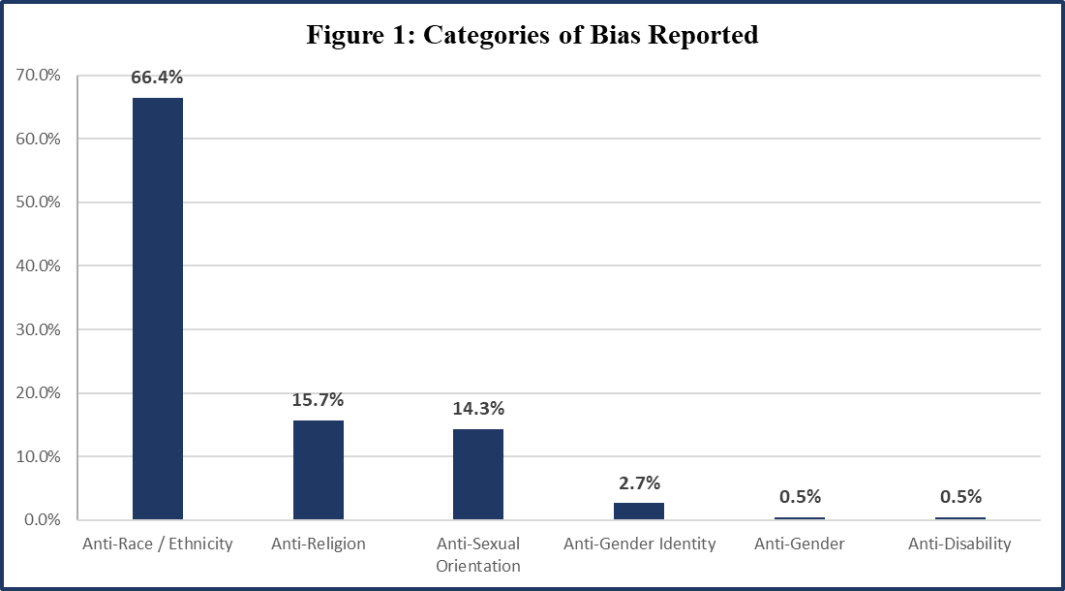

**Categories of Crimes Reported**

Of the 395 total offenses reported, Vandalism / Destruction of Property was the most frequently reported with 130 offenses, representing 32.9% of the total. Intimidation was the second most frequently reported offense, with 121 incidents representing 30.6% of the total offenses. Assaults also formed a significant portion of incidents, accounting for 19% and 11.4% respectively. Combining Aggravated and Simple Assaults would yield 120 assaults where offenders physically confronted a victim, which is consistent with last year’s total of 113.

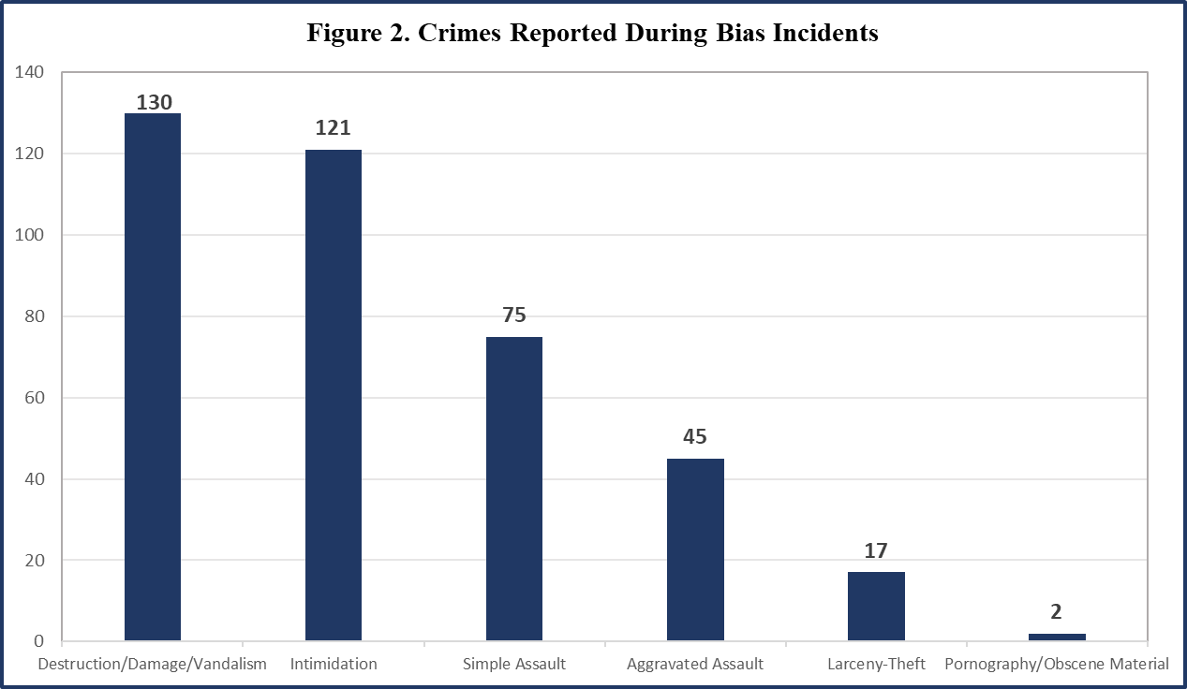

**Victim and Offender Profile**

* Please note: Categories with only 1 incident are not displayed in Figure 2 but can be found in Table 1.

An Individual / Person (including private property) was the target in 76.3% of cases (down from 78.4% in 2019). Business targets were second, with 9.2% (up from 8.1%). Government targets were the third most frequently targeted group with 8.3% of the incidents (up from 5.9% in 2019). Religious targets were chosen in 4 incidents or .9% of incidents (down from 2.4% the previous year).

In the 178 NIBRS incidents where the victim’s race was reported, whites were victims 71.9% of the time (up from 53.8% in 2019), while African Americans were victims in 24.2% of cases (down from 38% in 2019). In 2020, over 40% of biases were reported as Anti-Black, however, only 24% of victims were listed as African American. In many of the anti-Black incidents, the race of the victim was not entered, in others, the race was listed as white. This may be due to the large number of incidents stemming from the theft or destruction of Black Lives Matter signs and flags. The victims were male in 52.5% of cases. This year, the most common age group reporting hate crimes was 26–30-year-olds and this year there was a more equal distribution among age groups than last year. (See Table 8 & 13.)

The perpetrators of hate crimes were white in 77.5% of cases (up from 72% in 2019) and African American in 22.1% of cases (down from 24.4% in 2019), in the 258 cases where this information was identified. The perpetrator was male in 78.1% of known cases (down from 83.6% in 2019), and of the cases where the offender(s)’s age group was identified, the most frequently reported age group was 16-20 with nearly 13%. The second highest reported age group was 60+ with 12.2%.

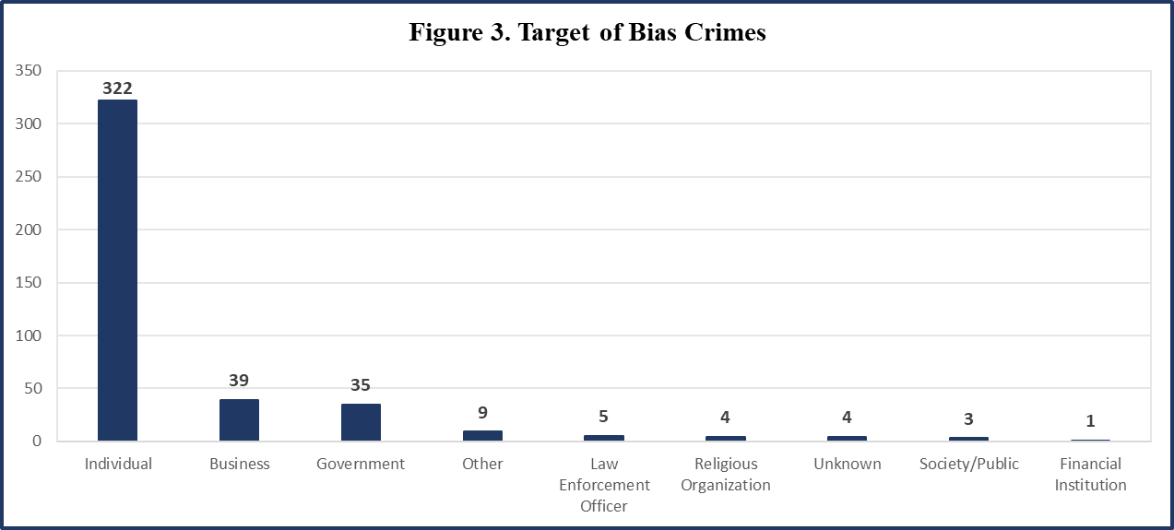

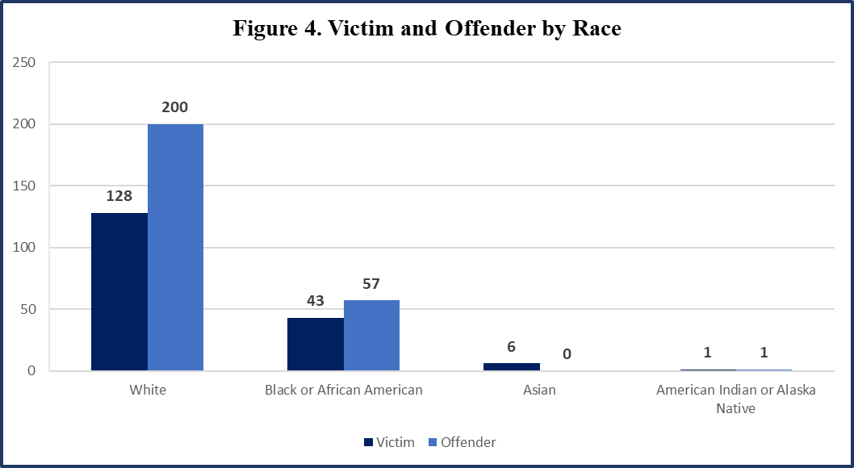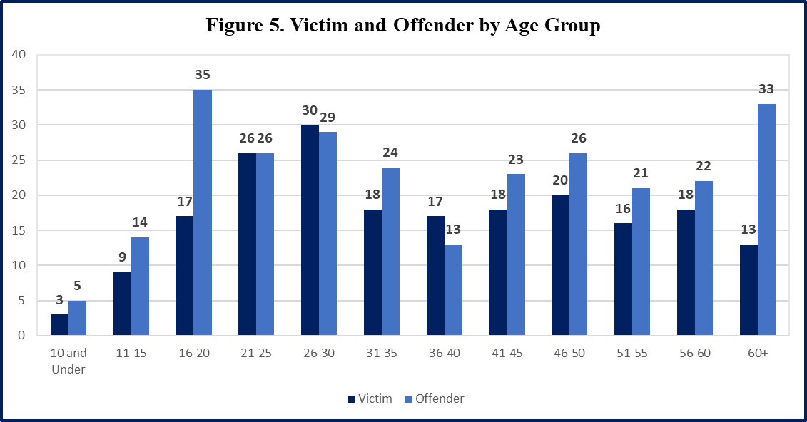

* Data source: For this chart, offender data is based upon combined UCR & NIBRS data, while victim data is based upon NIBRS data only.

* Data source: Only NIBRS data was used for this chart due to UCR reporting limitations.

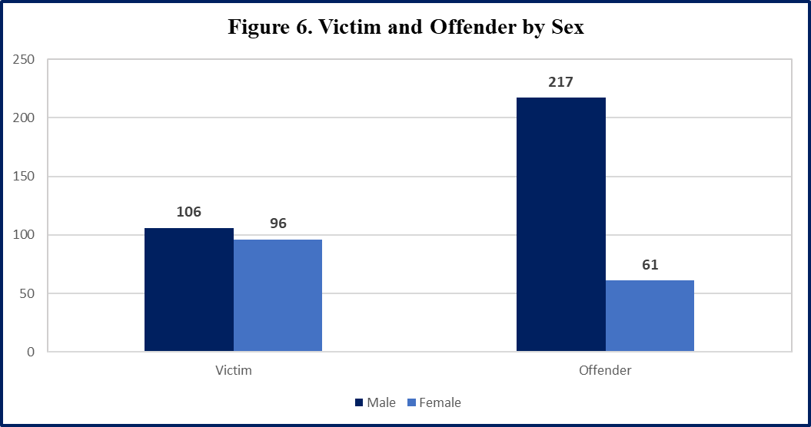

* Data source: Only NIBRS data was used for this chart due to UCR reporting limitations.

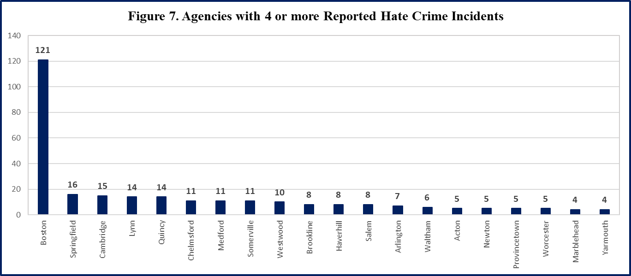

* Please note: For a full listing of Hate Crimes by Jurisdiction, please see Table 19.

**Characteristics of the Incidents**

The most common location for hate crime incidents to occur in 2020 was a residence / home (43%, up from 20.7% in 2019); followed by highway / road / street / sidewalk (17.5%,) and other (5.6%). The increase in residential incidents may be due to the COVID-19 Pandemic, which left many individuals tied to their residences with the exception of leaving for essential tasks. This most likely also lead to the decrease in incidents at schools. (See Table 11.)

Weapons of some type were reported in 93 incidents, which is up from 46 in 2019. In cases where the type of weapon was identified, hands / fist / feet were used the most frequently (50.5%, down from 56.5% in 2019). Other weapons were the second most frequently, listed in 24.7% of cases. Blunt objects were utilized in approximately 12.9% of cases. A firearm was only used in 1 incident in 2020, this is a significant decrease over the 6 in 2019. (See Table 12.)

In 2020, there were 45 incidents where injuries were reported. Minor injuries were reported in 36 incidents. This year, there were some other major injuries. There were 3 lacerations, 2 other major injuries and 2 internal injuries. (See Table 17.)

**Appendix**







|  |  |  |  |  |  |  |
| --- | --- | --- | --- | --- | --- | --- |
| **Table 4. Crimes by Primary Victim's Race** | | | | | | |
| **Criminal Offense** | **White** | **Black or African American** | **Asian** | **American Indian or Alaska Native** | **Missing / Unknown** | **Grand Total** |
| Destruction/Damage/Vandalism of Property | 43 | 7 | 0 | 0 | 95 | 145 |
| Intimidation | 34 | 12 | 1 | 0 | 7 | 54 |
| Simple Assault | 26 | 15 | 4 | 0 | 5 | 50 |
| Aggravated Assault | 9 | 8 | 1 | 1 | 4 | 23 |
| Burglary/Breaking & Entering | 7 | 0 | 0 | 0 | 5 | 12 |
| All Other Larceny | 4 | 0 | 0 | 0 | 5 | 9 |
| Shoplifting | 0 | 0 | 0 | 0 | 4 | 4 |
| Counterfeiting/Forgery | 1 | 0 | 0 | 0 | 2 | 3 |
| Fondling | 2 | 0 | 0 | 0 | 0 | 2 |
| Motor Vehicle Theft | 2 | 0 | 0 | 0 | 0 | 2 |
| Theft From Motor Vehicle | 0 | 1 | 0 | 0 | 1 | 2 |
| Extortion/Blackmail | 0 | 0 | 0 | 0 | 1 | 1 |
| False Pretenses/Swindle/Confidence Game | 0 | 0 | 0 | 0 | 1 | 1 |
| Robbery | 0 | 0 | 0 | 0 | 1 | 1 |
| **Grand Total** | **128** | **43** | **6** | **1** | **131** | **309** |

* Data source: Only NIBRS data was used for this table due to UCR reporting limitations.







* Data source: Only NIBRS data was used for these tables due to UCR reporting limitations.



* Data source: Only NIBRS data was used for these tables due to UCR reporting limitations.







* Data source: Only NIBRS data was used for this table due to UCR reporting limitations.





* Data source: Only NIBRS data was used for these tables due to UCR reporting limitations.



* Data source: Both NIBRS & UCR data were used for this table.



* Data source: Only NIBRS data was used for these tables due to UCR reporting limitations.



* Data source: Only NIBRS data was used for these tables due to UCR reporting limitations.

* Data source: Only NIBRS data was used for this table due to UCR reporting limitations.





* Data reflects counts of incidents













