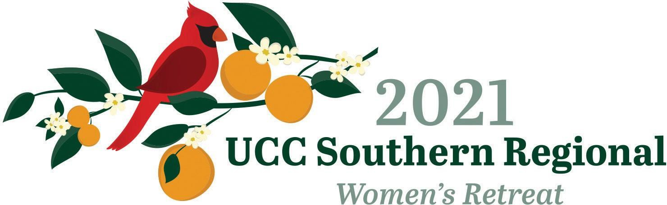
Hosted by the Florida UCC Women
facebook.com/2021uccsouthernregionalwomensretreat

SAVE THE DATES!

Virtually on Zoom: October 2, 2021
1-4 PM EDT
In Person: October 14 – 16, 2022

Camp Weed and Cerveny Conference Center 11057 Camp Weed Place Live Oak, Florida 32060

GOD OF MYSTERY – SPIRIT OF HOPE

ROMANS 12:12-13
“Rejoice in hope, be patient in suffering, persevere in prayer... extend hospitality to strangers.”

