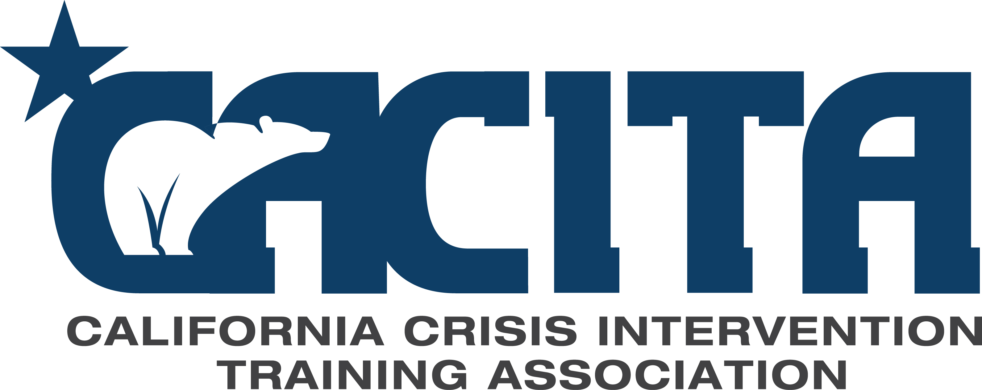

**California Crisis Intervention Training Association Annual Conference**

**October 4 – 5, 2018 in Sacramento, California**

***REGISTRATION IS NOW OPEN***

Location McClellan Conference Center, Sacramento, CA

5411 Luce Ave. McClellan, CA 95652

Registration [**cacita.net**](http://www.cacita.net)

CACITA Members - $175 *Day of Registration $200*

Non-Members - $200 Day of Registration $225

Hotel **Crowne Plaza Hotel Sacramento Northeast**

Hotel Reservations: (877) 504-0054

CA Crisis Intervention Training Rate: $95.00/per night plus tax

**Limited rooms.**

Pre-Conference

Training Day

October 3, 2018 Special training opportunities for law enforcement, corrections, and detention personnel will be offered the day prior to the conference. This added training opportunity may be added to conference registration for an additional $50.00.

Course 1 - This 8-hour course consists of hands-on/practical training, lecture, and scenario based training for in-service law enforcement officials and Field Training Officers, in compliance with 13515.28(a)(1) of the California Penal Code.

Course 2 - This 8-hour course consists of hands-on/practical training, lecture, and scenario based training for in-service law enforcement officials who work in correction and detention assignments.

***Speakers and Topics are to be announced:* POST and other continuing education credits will be offered.**







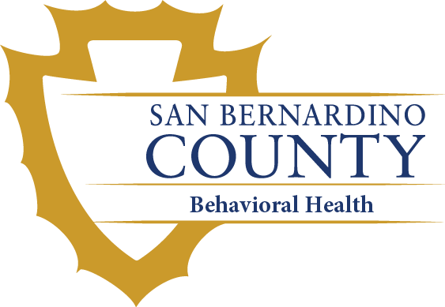



CONTACT: Marla Kingkade 619-200-9769

Community Research Foundation/PERT

[mkingkade@comresearch.org](mailto:mkingkade@comresearch.org)