Lumia 550
Fact Sheet
October 2015
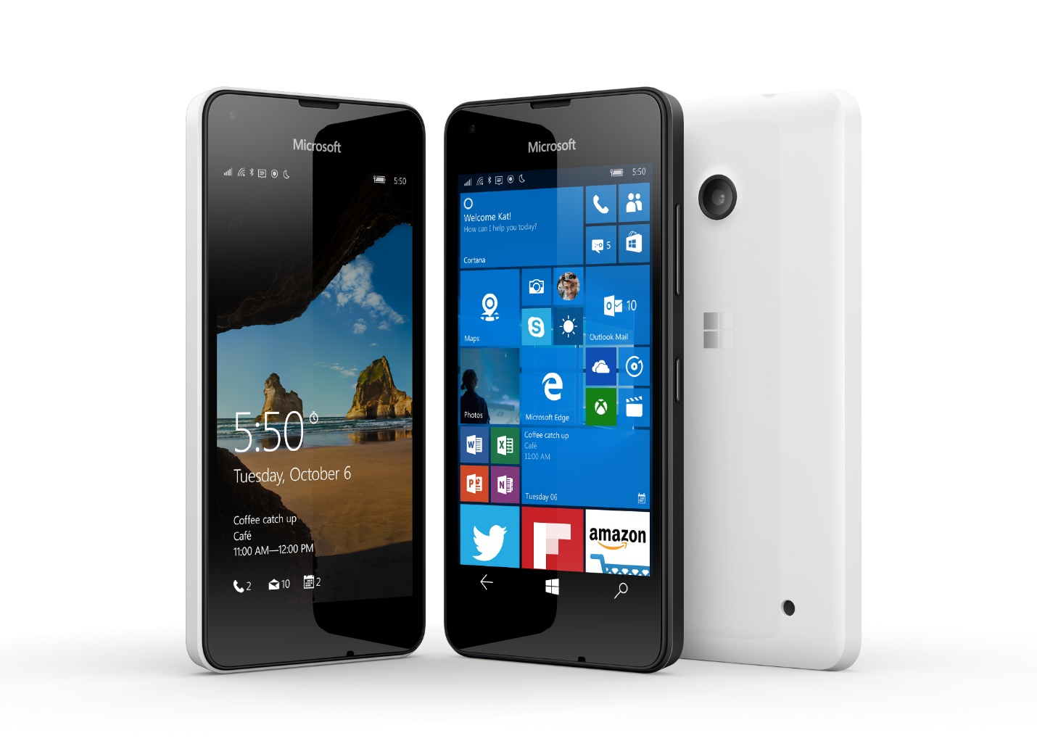
Meet Lumia 550, Microsoft’s most affordable 4G LTE¹ smartphone that enables you to get great things done faster. Enjoy the Windows 10 experience, including Cortana2 and the Windows Store, as well as Microsoft Office apps tailored to your screen size so that you can view, create and edit documents on the go. Equipped with superfast 4G LTE connectivity, Lumia 550 takes the affordable Lumia to the next level with a 4.7-inch HD display, 5MP rear-facing camera with LED flash, and 2MP front camera for quality Skype calls³ — all for just $139⁴.

Top Features and Benefits
- Windows 10 experiences. Enjoy Windows 10, signature Microsoft services and experiences, and your favorite apps on the premium 4.7-inch HD display.
- Stay productive. Microsoft Office apps tailored to your screen size and OneDrive cloud storage enable you to be productive and access your files on your phones⁵.
- Personal assistant. Get things done faster with your digital personal assistant Cortana, deeply integrated with your phone’s native apps².
- 4G LTE connectivity. Superfast 4G LTE Internet connection and cloud services help keep you up to date on work and fun¹.

Technical Specifications
Operating  system | Windows 10
Exterior | Dimensions: 136.1 x 67.8 x 9.9 mm  Weight: 141.9 g  Casing: polycarbonate  Colors: black, white⁶  Physical buttons: power, volume
Storage | 8GB⁷ and up to 200GB expandable storage⁷
Display | Screen: 4.7-inch HD display  Resolution: 1280x720 (315 ppi)  Aspect ratio: 16:9
CPU | Qualcomm® Snapdragon™ 210 processor featuring a quad-core CPU running up to 1.1 GHz
Network | Wi-Fi: (2.4 GHz) b/g/n  Bluetooth 4.1 LE  Nano SIM (4FF)
Battery | Removable 2100 mAh battery  Battery life⁹:  Standby Up to 28 days  2G talk Up to 15.9 hours  3G talk Up to 13.9 hours
Cameras and A/V | 2MP front-facing camera  5MP rear-facing camera with AF f/2.4, 720p @ 30 fps video, and single LED flash
Ports | microSD™ slot, supports up to 200 GB of expandable storage⁴  Charger AC-18
Sensors | Accelerometer  Proximity sensor  Ambient light sensor
Power supply | Charger AC-18
Location | A-GPS  A-GLONASS  BeiDou  Cellular  Wi-Fi network positioning
In the box | Lumia 550  2100mAh battery  Charger AC-18  Headset WH-108¹⁰  Quick Guide
Warranty | One-year limited hardware warranty¹¹

Pricing
8 GB⁶ | $139.00 ERP¹²

¹ Coverage, service and 4G/LTE are not available everywhere. See carrier for coverage details.
² Cortana available in select markets at launch; experience may vary by region and device.
³ Skype available only in select countries. Calling to select countries only. Excludes special, premium and nongeographic numbers. See FAQ for details.
⁴ Before local taxes and subsidies. Actual prices may vary.
⁵ Microsoft account required; Internet and mobile fees apply.
⁶ Device color availability may vary
⁷ Pre-installed system software and apps use a significant amount of storage. See http://www.microsoft.com/mobile/lumia-storage for more details.
⁸ Supports SDXC 3.01 standard-compliant cards. 200GB cards currently available.
⁹ Talk, standby and playback times are estimates only. Actual times are affected by, for example, network conditions, device settings, features being used, battery condition and temperature. Battery has limited recharge cycles and battery capacity reduces over time. Eventually the battery may need to be replaced.
¹⁰ Available in select markets.
¹¹ In the U.S.; warranty terms vary by market
¹² Estimated retail price (USD). Actual prices may vary.

Contact Information
For more information, press only:
Rapid Response Team, WE Communications, (503) 443-7070, rrt@we-worldwide.com

For more product information and images:
Visit the Lumia Newsroom at https://news.microsoft.com/presskits/lumia/.

For more information about Lumia:
Visit Lumia at http://www.microsoft.com/en/mobile/phones/lumia/.

