Surface Pro 4
Fact Sheet
October 2015

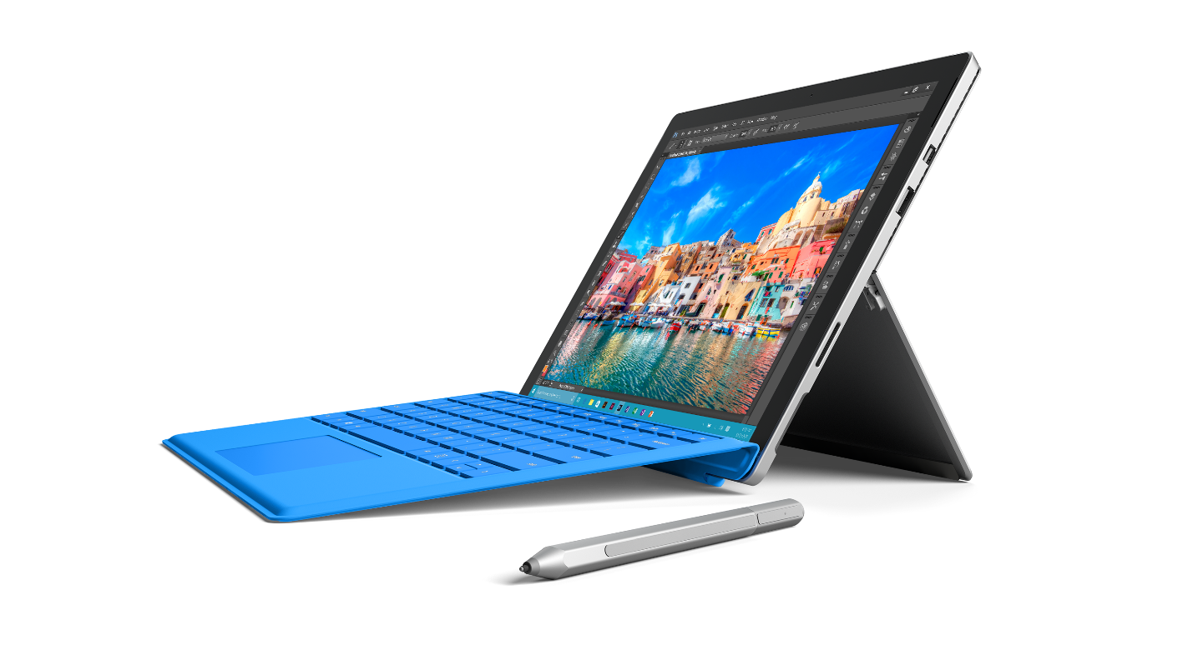
Meet Surface Pro 4, the tablet that can replace your laptop. Featuring Windows 10 Pro, 6th Generation Intel® Core™ m, Core™ i5 and Core™ i7 processors, and a 12.3-inch PixelSense™ Display, Surface Pro 4 helps you power through everything you need to do. Starting at just $899, it’s thinner, lighter and faster than any previous Surface Pro model.

Top Features and Benefits
- Exceptional performance. With the new 6th Generation Intel® Core™ m, Core™ i5, and Core™ i7 processors, Surface Pro 4 is not only more powerful than Surface Pro 3 — it’s quieter, runs cooler, and is even more efficient. With up to nine hours of battery life for video playback and the optional Surface Pro 4 Type Cover (sold separately), you can get more work done without interruption.
- Experience Windows 10. With full Windows 10 Pro, Surface Pro 4 is compatible with virtually all your favorite software. You can run apps and desktop programs like Microsoft Office side-by-side, and the enterprise-level security of Windows Hello helps keep your contents secure. Plus, full pen support and the redesigned Surface Pen packing 1,024 levels of pressure sensitivity enable you to write directly on Web pages in the Microsoft Edge browser or access your personal digital assistant, Cortana, with the click of a button.
- Best-in-class screen. With a stunning 12.3-inch PixelSense™ Display and 3:2 aspect ratio for comfortable viewing, Surface Pro 4’s screen builds on the innovative design of the Surface Pro 3 screen. One of the brightest and most accurate displays Surface has ever made, it features 267 ppi and 1300:1 contrast ratio, supports 100 percent sRGB color, and has 5 million pixels.

Technical Specifications
Operating System | Windows 10 Pro
Exterior | Dimensions: 11.50 x 7.93 x 0.33 in (292.10 x 201.42 x 8.4 mm)  6th Generation Intel® Core™ m weight: 1.69 lbs. (766 g)  6th Generation Intel® Core™ i5 and Core™ i7 weight: 1.73 lbs. (786 g)  Mechanical features: Magnesium body, kickstand with full-friction multiposition hinge, magnetic attach for keyboard fold stability  Color: Silver  Physical buttons: volume, power
Display | Screen: 12.3-inch PixelSense™ Display  Resolution: 2736x1824 (267 ppi)  Contrast ratio: 1300:1  Aspect ratio: 3:2  100 percent sRGB color, individually calibrated  Touch: 10-point multitouch with GPU-based processing
Processor | 6th Generation Intel® Core™ m3, Core™ i5 or Core™ i7
Graphics | Intel® HD graphics 515 (Intel® Core™ m3)  Intel® HD graphics 520 (Intel® Core™ i5)  Intel® Iris™ graphics 540 (Intel® Core™ i7)
Memory | 4 GB, 8 GB or 16 GB RAM
Storage | Solid-state drive (SSD) PCIe 3.0: 128 GB, 256 GB, 512 GB or 1 TB
Security | TPM 2.0 chip for enterprise security
Pen | Surface Pen  1,024 levels of pressure sensitivity  Magnetic storage
Network | 802.11ac 2x2 MIMO Wi-Fi wireless networking; IEEE 802.11a/b/g/n compatible  Bluetooth 4.0 LE wireless technology
Battery | Up to 9 hours of battery life for video playback2
Cameras | Windows Hello face-authentication camera (front-facing)  8.0 megapixel rear-facing auto-focus camera, with 1080p HD camera  5.0 megapixel front-facing 1080p HD camera
Audio | Stereo microphones  Stereo speakers with Dolby® audio
Ports | Full-size USB 3.0  Mini DisplayPort  microSD™ card reader (UHS-I performance)  Stereo headphones/microphone jack  Type Cover  Surface Connect for power and docking
Sensors | Ambient light sensor  Accelerometer  Gyroscope  Magnetometer
Power supply | 24W power supply (Intel® Core™ m3)  36W power supply with USB charging port (Intel® Core™ i5 and Core™ i7)
In the box | Surface Pro 4  Surface Pen  Power supply  Quick Start Guide  Safety and warranty documents
Warranty | One-year limited hardware warranty⁶

Pricing
128 GB 6th Generation Intel® Core™ M3 with 4 GB of RAM | $899 ERP
128 GB 6th Generation Intel® Core™ i5 with 4 GB of RAM | $999 ERP
256 GB 6th Generation Intel® Core™ i5 with 8 GB of RAM | $1,299 ERP
256 GB 6th Generation Intel® Core™ i7 with 8 GB of RAM | $1,599 ERP
256 GB 6th Generation Intel® Core™ i7 with 16 GB of RAM | $1,799 ERP
512 GB 6th Generation Intel® Core™ i7 with 16 GB of RAM | $2,199 ERP

¹ Estimated retail price. Actual retailer prices may vary.
² Testing conducted by Microsoft in September 2015 using preproduction Intel® Core™ i5, 256GB, 8GB RAM device. Testing consisted of full battery discharge during video playback. All settings were default except Wi-Fi was associated with a network and Auto-Brightness disabled. Battery life varies significantly with settings, usage and other factors.
³ Sold separately
⁴ Cortana available in select markets at launch. Cortana experience may vary by region and device.
⁵ System software uses significant storage space. Available storage is subject to change based on system software updates and apps usage. See http://www.microsoft.com/surface/storage for more details.
⁶ In the U.S.; warranty terms vary by market.

Contact Information
For more information, press only:
Rapid Response Team, WE Communications, (503) 443-7070, rrt@we-worldwide.com

For more product information and images:
Visit the Surface Newsroom at http://www.microsoft.com/en-us/news/presskits/surface.

For more information about Surface:
Visit Surface at http://www.microsoft.com/surface.

