Microsoft Band 2
Fact Sheet
October 2015
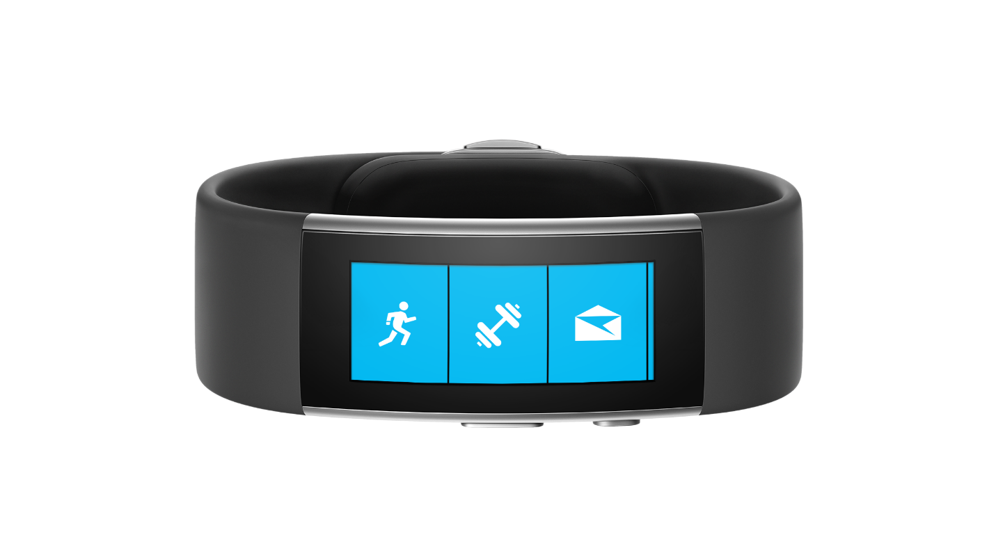
Meet Microsoft Band 2, the smart band created to enable you to live healthier and achieve more. Microsoft Band 2 tracks your heart rate, exercise, calorie burn and sleep quality, and provides notifications about your emails, texts and calendar alerts. Advanced sensors track data specific to running, biking and golfing, and technology from Microsoft Health gives you actionable insights based on your data. Microsoft Band 2 and Microsoft Health let you share your activity data with your favorite fitness apps, and give you access to experiences developed with premier sports and lifestyle brands.

Top Features and Benefits
- Live healthier. Microsoft Band 2 and Microsoft Health help you live healthier by tracking your heart rate, exercise, calorie burn and sleep quality. Microsoft Health is available as a universal Windows app, a dedicated app for iOS and Android devices, and via a Web Dashboard, enabling people to set wellness goals and receive actionable insights.
- Get fit. Reach your fitness goals with Guided Workouts and custom tracking whether running, biking or golfing. Your perfect workout companion, Microsoft Band 2 not only tracks speed and distance with a built-in GPS but even elevation gains with its built-in barometer.
- Be productive. Stay connected at a glance with the notifications that matter most to you right on your wrist. Easily check email previews, calendar alerts, calls or text messages, and view social updates. Stay organized with personal reminders you can set with your voice using Cortana.
- Advanced technology. Microsoft Band 2’s curved screen makes it comfortable to wear. The vibrant, full-color AMOLED display is bright and easy to read, and is protected with durable Corning® Gorilla® Glass 3. Its 11 advanced sensors track your daily activity, exercise and sleep quality. And with built-in GPS, you aren’t tethered to a phone to track your data — it’s stored in the device itself then uploaded to Microsoft Health once Bluetooth® kicks in.

Technical Specifications
Material | Thermal plastic elastomer silicone vulcanate (TPSiV)
Display Size | 32mm x 12.8mm
Display Type | Curved AMOLED
Resolution | 320x128 pixels
Battery | 48 hours
Average Charge Time | Full charge in less than 1.5 hours
Battery Type | Li-polymer
Operating Temperature Ranges | -10°C to 40°C (14°F to 104°F)
Maximum Operating Altitude | -300m to +4877m
Sensors | Optical heart rate sensor  3-axis accelerometer  Gyrometer  GPS  Ambient light sensor  Skin temperature sensor  UV sensor  Capacitive sensor  Galvanic skin response  Microphone  Barometer
Additional Technology | Haptic vibration motor
Connectivity | Bluetooth® 4.0 LE
Supported mobile devices | Windows Phone 8.1 update or greater  iPhone®5, 5C, 5S, 6, 6 Plus with iOS® 8.1.2 or greater  Android™ 4.4 or later phones with Bluetooth®
Charge Cable Connector | Custom charge cable
Water Resistance | For water-resistance details and limitations, see http://microsoft.com/band/waterresistance.

Pricing
Microsoft Band 2 | $249.99 ERP

¹ Cortana only available with Windows Phone 8.1 update or later; available in English only.
² Advanced functionality like GPS use will impact battery performance. Battery has limited recharge cycles and cannot be replaced. See http://microsoft.com/band/battery for more information.

Contact Information
For more information, press only:
Rapid Response Team, WE Communications, (503) 443-7070, rrt@we-worldwide.com

For more product information and images:
Visit the Microsoft Band Newsroom at https://news.microsoft.com/microsoft-band-press-materials/.

For more information about Microsoft Band:
Visit Microsoft Band at http://www.microsoft.com/band.

